

BAPTIST CHURCH

June

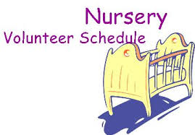
June 4………..…..Judy Broussard, Otisann McManus
June 11……………….…………Jana Moore, Terri Edwards
June 18………..…………..…Angie Fisher, Teresa Schane
June 25……………………Leigh Veilleux, Rachel Merrell
Jan 29…..Terri Edwards, Debby Dunkin

Weekly Service & Activity Schedule:

SUNDAY
Sunday School 9:45 a.m.
Morning Worship Services 11:00 a.m.
Evening Worship Services 6:00 p.m.

WEDNESDAY
Meal/Wednesday Bible Study. 6:30 p.m.

1662 CR 305

McDade, TX 78650

Phone: (512) 273-2743

Email: KnobbsSpringsBaptist@gmail.com



KnobbsSpringsBC.com

David Atwood – Pastor
(512) 470-5098

Patti Radford - Office Manager

KnobbsSpringsBaptist@gmail.com
512-273-2743



June Ushers

Joe Daniel, Joe Wilson,

Wayne Marecle, David Condron

June Hostesses/Hosts

Cissy Atwood, Judy Broussard,

Jean Griffith, Rachel Merrell
WHAT’S GOING ON?



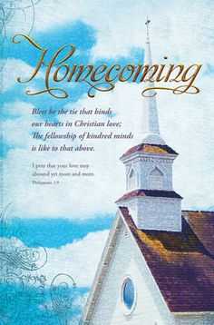

KSBC is celebrating 157 years of blessings!! Join us for singing, memories, fellowship, and lunch on the grounds

New Commandment Kids
Hands-on mission work thru puppet ministry and crafts to share with nursing homes, shut-ins, etc. Meeting the 1st and 2nd Sunday of each month @9:30 am
Ages Kinder thru 12th grade welcome

June

4…………...……New Commandment Kids

8……………………..……Adult Fellowship
11……………….New Commandment Kids
11……………………….…….Homecoming
18……………….……………..Father’s Day
22………………..………Adult Fellowship
22……………………….Stamp Card Class
25………………………..Business Meeting
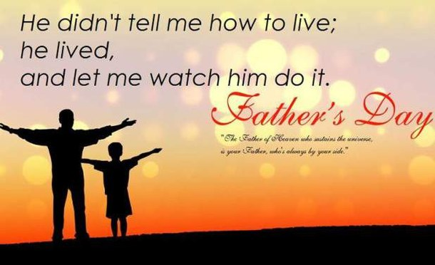

Make and Take Card Class with a 4th of July Theme
June 22 6 pm – 9 pm
The cost is $20 and attendees will take home 4 cards
Contact Brenda Williams if you are interested. 512-925-8572



June officially signals the beginning of the vacation season. School is out and vacation plans have been made. The only thing left to do is to pack your bags and fill the car with gas. But there is one activity in a Christian’s life that we should never anticipate a vacation from; spreading God’s love through our words and deeds. The vacations we take should be looked at as opportunities to share God’s love with people we wouldn’t ordinarily come into contact with.
The second verse of the old hymn “Make Me A Blessing” says; “Tell the sweet story of Christ and His love, tell of His power to forgive; others will trust Him if only you prove, TRUE EVERY MOMENT YOU LIVE”.
A vacation is another opportunity to “Go and make disciples of all nations”. I hope you remember to take your Bible with you on your vacation, and as you pack your swim suit, flip flops, and shorts, don’t fail to “put on the full armor of God”, just as you do any other day.
Our Homecoming service is June 11 and Father’s Day is the Sunday after that, June 18. I hope you are anticipating both of these services that will be a blessing to us all. There will be no evening service on either of these Sundays. Please make all of our services and activities a priority on your calendar.
Pray for a safe summer for everyone!

God Bless You All,
David L. Atwood

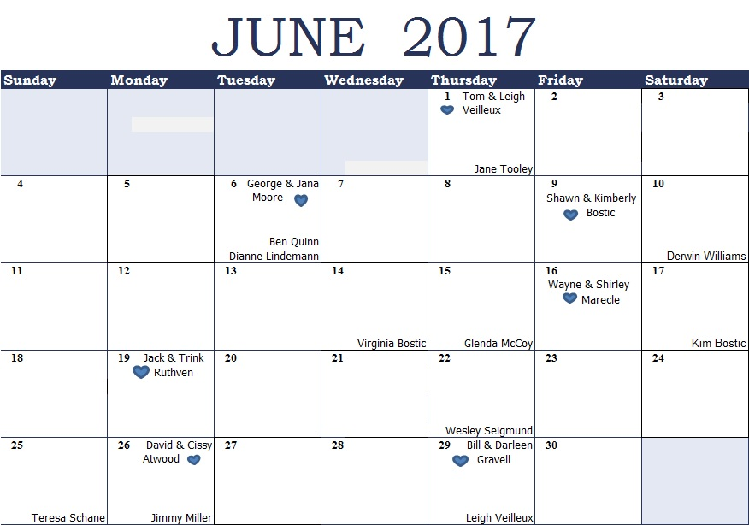
K s b c
Keeping His Word through Sunday School, Bible Study and Church Attendance/Worship
Sunday School Bible Studies for June :
June 4th Love Like Christ John 15:9-17 June 11th Forge True Friendship I Samuel 18:1-4; 19:4-7; 20:10-13 June 18th Respect Authority I Samuel 24:3-12
June 25th See Their Worth 2 Samuel 11:1-9, 14-17

9:45 a.m. each Sunday – A place for everyone
WE’D LOVE FOR YOU TO JOIN US!

